Process Book

How NFL Draft Pick Relates to NFL Success

**Overview and Motivation**

We chose to look into the relationship between NFL Draft Position and NFL Success because it is not always clearly communicated in sports. Each of us being a fan of an NFL team (with limited success on Joe and Rebecca’s side), we want to see what number picks might help our teams the most. We are also interested in looking at the distribution of different positions throughout different rounds of the NFL Draft. It is always thought that quarterbacks are most frequently selected in the first round, but this may simply be a common misconception. Additionally, we want to see if players like Tom Brady, who was a 6th round pick, are as anomalous as they appear to be.

Our overall goal is to provide an interactive tool where you can determine different drafting facts and trends and make informed decisions about the best places to draft certain positions.

**Related Work**

We were inspired by the dataset to provide a comprehensive view of the influence of a draft pick number over a player’s success, as well as the many interactive tools we discussed in class like the principles of Focus + Context, brushing, and aggregation.

**Questions**

The main question we are asking is how NFL draft pick number relates to NFL success over a career. As we initially viewed the data, we noticed that, with such a large data set, there were many questions that we could answer relating to NFL data. Some secondary questions we asked were:

* What teams acquired players from certain positions who proved to be, perhaps, more successful than predicted (by pick number)?
* For what years were teams good at picking certain positions?
* Is it as rare as we think it is for worse picks to perform well in the NFL?

**Data**

We found our main dataset on kaggle: <https://www.kaggle.com/ronaldjgrafjr/nfl-draft-outcomes>. We shortened the data to include only years 1995 to 2015, and kept the attributes titled PlayerID, DraftPick, DraftYear, Position (filtered into six simple groups), CarAv (career value), First4AV (first four years of playing value), and NFL Draft Team.

**Implementation**

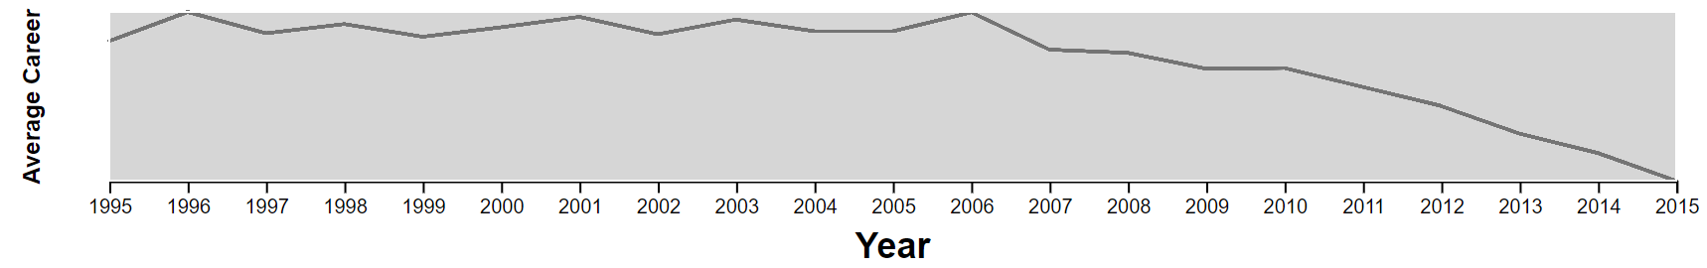

We implemented a year-based selection in which you can drag the endpoints of the rectangle to select a range of years and drag the rectangle itself to change the years within the range. This is so that we are able to choose based on more recent/older data. By updating the rectangle, the main scatterplot and additional plot is automatically updated. The plot shown in the year focus plot is a line plot that shows the average career statistic (Career Average or First Four Years).



Our main plot is a scatterplot. Each point represents a player. The colors are coordinated based off of the player’s positions: for example, blue represents a quarterback. The x-axis represents the increasing pick number of the players: meaning that the higher the pick (the “better” player in college football), the lower the x value. The y-axis represents the career approximate value, which is a standardized statistic based off of many career statistics. The higher a value, the better the player has performed in the NFL.

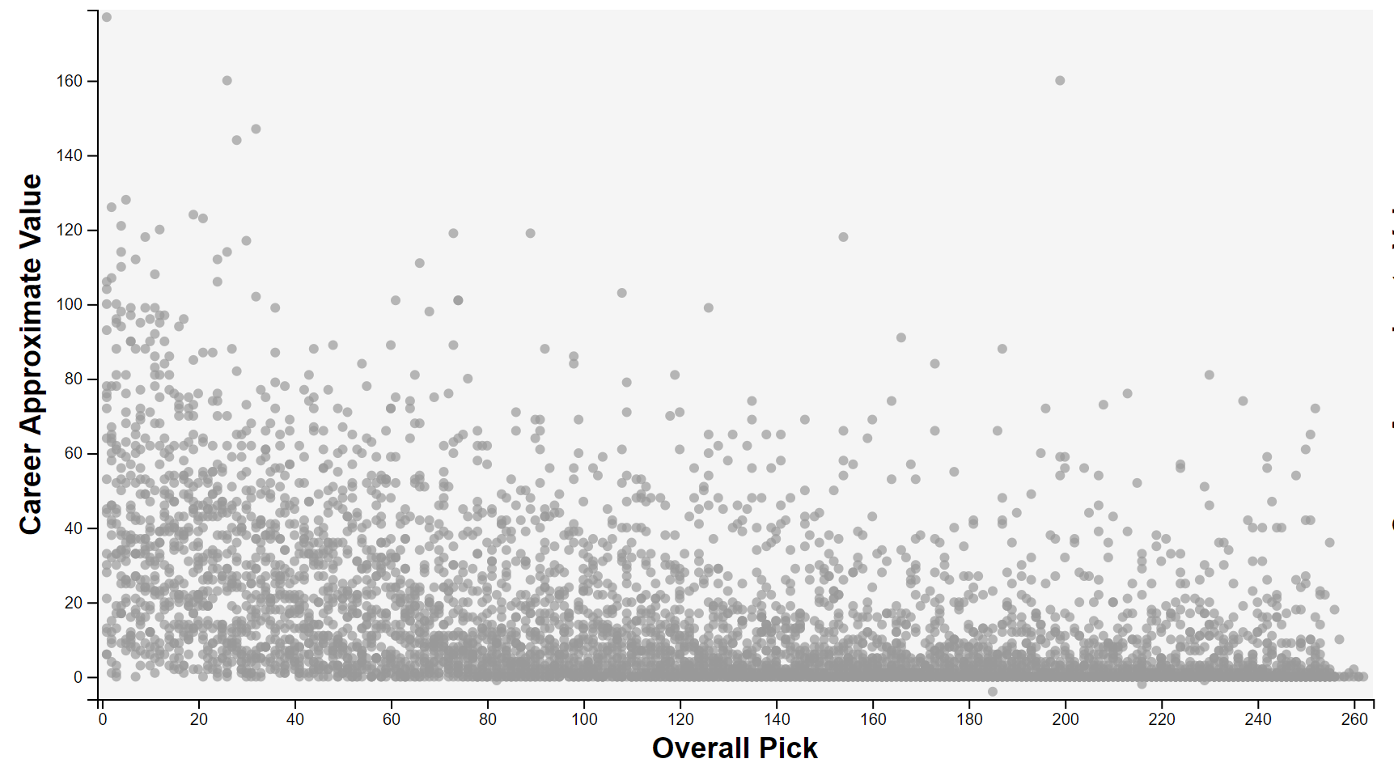

An update we made to this main plot is that the background color was lightened, and the opacity of the points was increased in order to increase contrast. The default plot with All points selected also has no colors corresponding to position, in order to cut down on business.

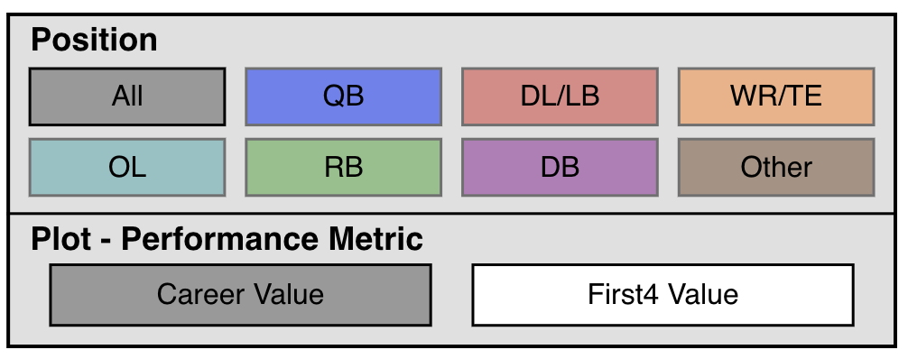

Our options box is one of our main interactive elements. You can click on any position and performance metric to choose what to look at in the main scatterplot.

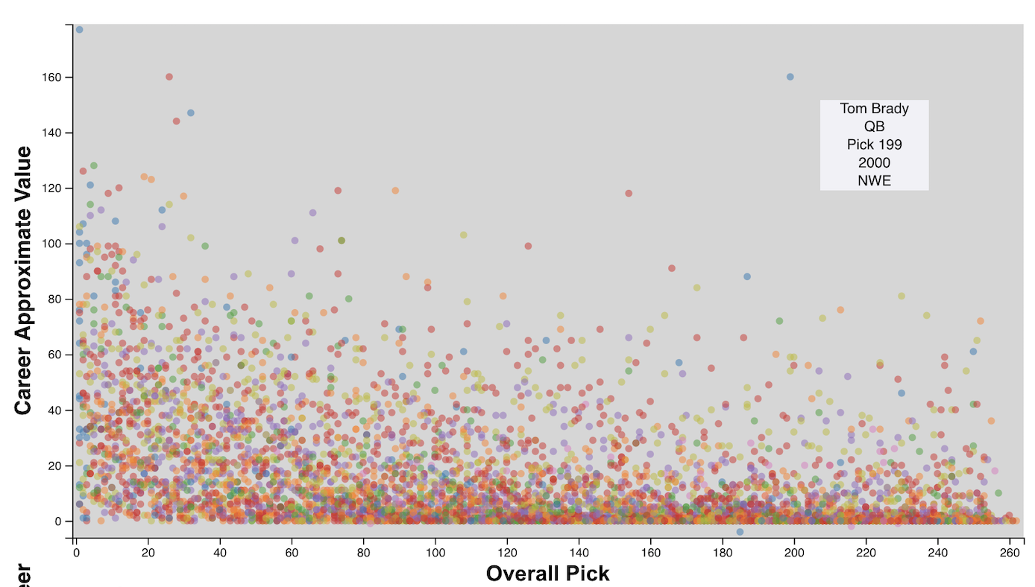

We are able to hover over a point to show the name, position, pick number, year, and team of that player. This is helpful to indicate what people may be outliers.

This portion of the visualization helps to filter the data by the round players were drafted in. It is key since it de-clutters the data and allows more precise observations.

**Exploratory Data Analysis:**

Initially, we made a single scatterplot relating Pick to Career Average. The plot was quite overwhelming and did not show a clear correlation between lower draft pick and higher career average. From this, we knew it would be important to show the data in separate views to see if there is a more realizable relationship between pick number and NFL success. We decided that we should be able to filter the scatterplot showing pick vs success via a variety of methods – the ones we chose are by round, position, and year range. Additionally, our second view was decided to be a team aggregated stat for the data points view on the scatterplot.

**Design Evolution**

When we were looking at how to transition data when we were changing positions, at first, the interaction had all old points rising toward the top left point while fading out, whereas the new points were falling from the top left point while fading in. After discussion, we decided that it would be a less confusing transition to just have old points fade out and new points fade in.

We decided to use a double-headed slider for selecting by year. This tactic is useful for selecting a range of discrete entities. The year slider shows a line plot of the average selected career statistic (Career Average or First Four Year), rather than the original simple point plot. The line shows more of the trend which would let the user know what range of years might be of interest. This is derived from a Focus + Context

We chose to have a second view that would be able to be modified by brushing that would show how a performance metric relates to a different NFL team for the set of points located within the brush. This is useful for providing some more context behind the data instead of just having our main view with all the different players. This way, the user is presented with both the pick vs career average and the ‘usefulness’ of the players to teams within the selected time period/round/position. This made the overall presentation juxtaposed with two graphs that are linked together with brushing mechanisms.

We decided to add another selection mechanism to choose the round (1 – 7) of picks. This allows the viewers to have an even more in-depth view of the data.

**Analysis**

Our visualization effectively displays our data on a large scale in a scatterplot by plotting pick number against career success. Through seamless interaction mechanisms, we allow the user to focus on a set of data that they are interested in studying. We do believe there is a correlation between pick number and career success, but there are rare players who succeed on a large scale who were picked late in the draft. We were able to discover players whose career success was deemed harmful and can see what teams had more success than others when choosing players by position/time frame/round. Future improvements to our projects would involve letting the selection be more data driven than by abstracted selections, meaning a drag and hover brushing over data points in the scatterplot could show an aggregated analysis of those players. This would allow users to do more specifies searches for answers.